Maven Hospital Challenge Analysis
Executive Summary:
This report presents a high-level analysis of patient data from Massachusetts General Hospital, focusing on patient encounters, financial performance, and procedure utilization. Key findings include high readmission rates among older patients, rising healthcare costs over time, and significant variation in procedure costs and durations. Recommendations include strengthening insurance partnerships, promoting cost-effective care settings, and optimizing high-cost procedures.
Hospital+patients analaysis - Power BI
Introduction:
This project is based on the June 2024 Maven Analytics data challenge. The goal was to build a high-level KPI report for the executive team using a subset of patient records. The report aims to provide stakeholders with visibility into the hospital’s recent performance and answer the following key questions:
- How many patients have been admitted or readmitted over time?
- How long are patients staying in the hospital, on average?
- How much is the average cost per visit?
- How many procedures are covered by insurance?
The dashboard should scale to accommodate new data over time, but the CEO has asked you to summarize any insights you can derive from the sample provided.
About The Data
Synthetic data on approximately 1,000 patients of Massachusetts General Hospital from 2011–2022, including information on patient demographics, insurance coverage, and medical encounters & procedures. The dataset is structured across five CSV files.
Skills
Power Bi, Power Query
Data Modelling, Data Visualization

ER Diagram:

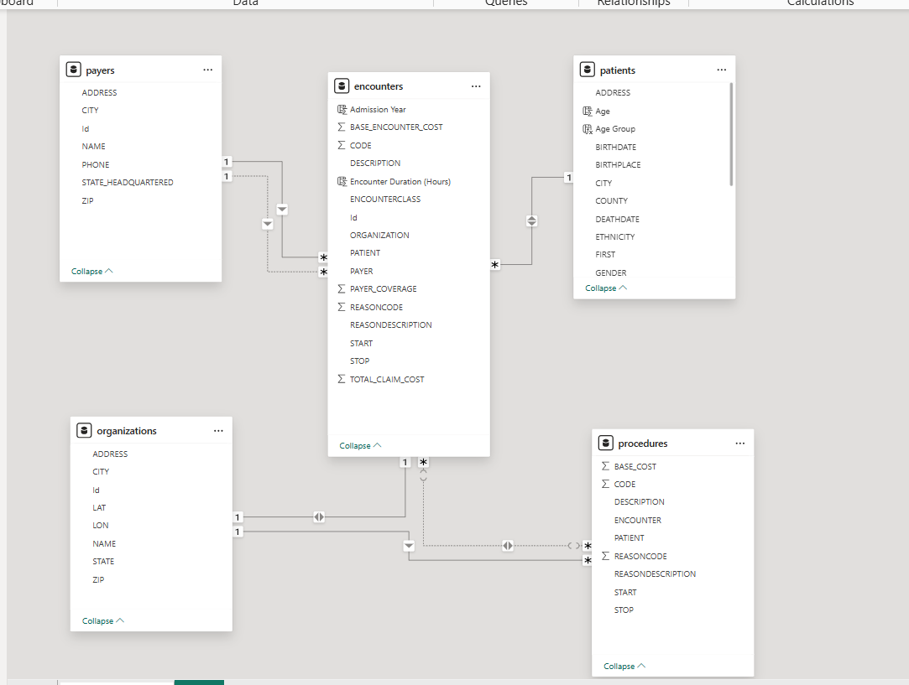
Dashboard Analysis

Overview Page: The Overview Page provides a comprehensive snapshot of patient interactions and outcomes. It includes key metrics such as total encounters, patient counts, readmissions, and deaths. Age-based bar charts show distributions for encounters, patients, readmissions, and death rates. Line charts track trends in encounters and admissions from 2010 to 2021. Filters for gender, race, and ethnicity enable granular analysis.

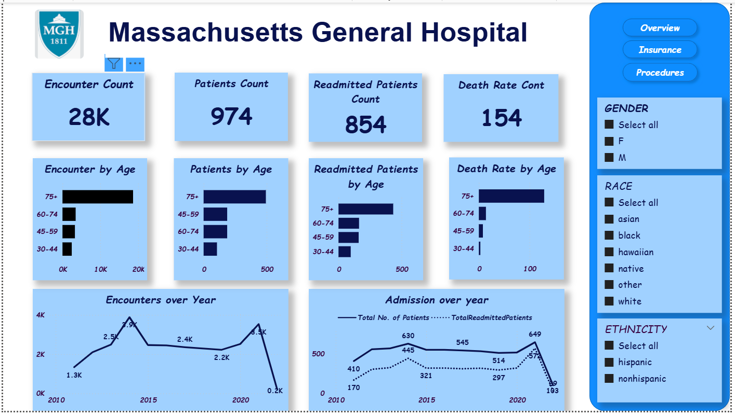
Insurance and Financial Analysis: This section offers a financial overview of patient care, focusing on insurance coverage, claim costs, and payer contributions. Claim costs have risen from approximately $4 million in 2010 to over $12 million in 2020. Bar charts show average visit costs and insurance coverage by encounter class. Filters allow demographic segmentation for equity analysis.
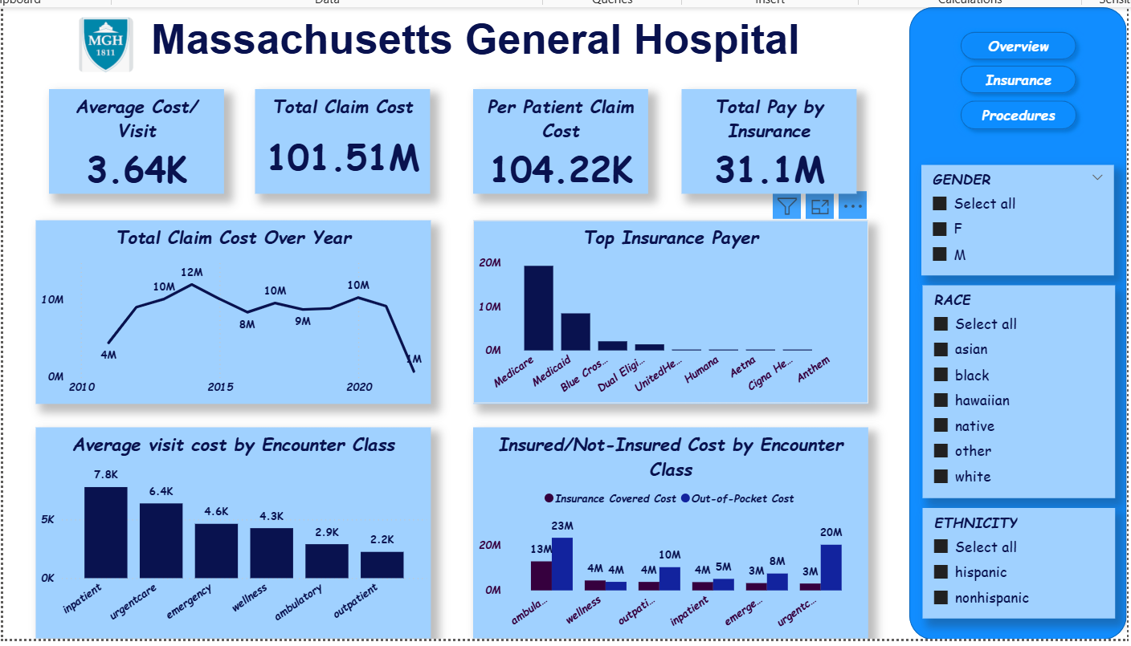

Procedure Analysis This page examines procedures by cost, duration, and patient stay. Hip replacement shows the longest average stay (~1,900 hours). Inpatient procedures average 37 hours, while ambulatory procedures average 9 hours. Patients aged 75+ have the longest stays. Electrical cardioversion is the most expensive procedure (~$36M), followed by auscultation of heart sounds and uterine evaluations (~$6M each).
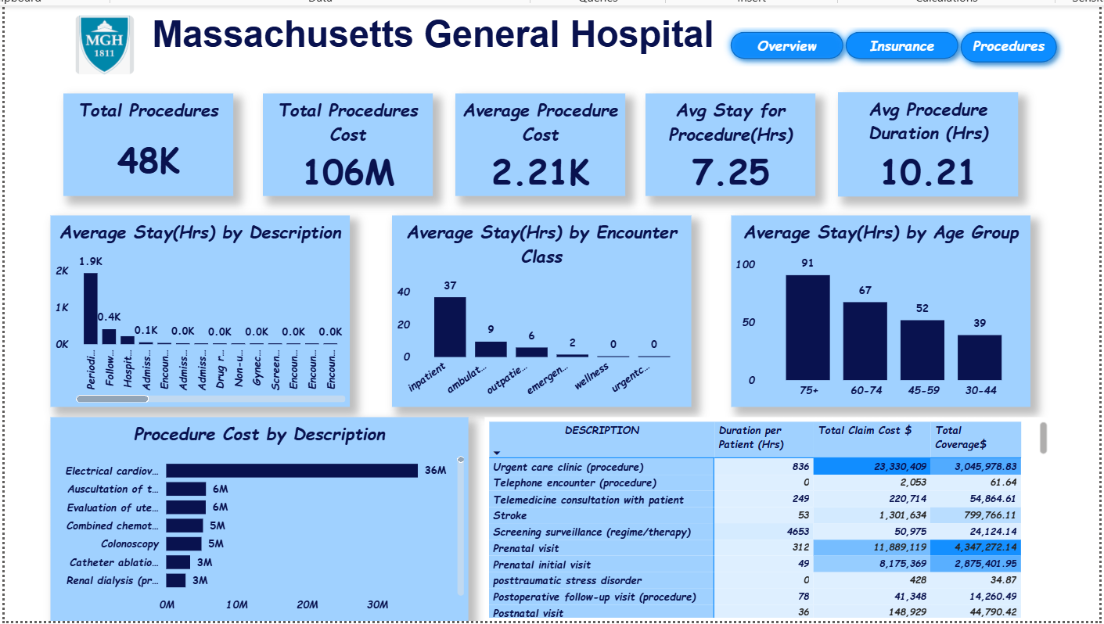
Key Findings:
- High readmission and death rates among older patients (75+).
- Rising claim costs over time, indicating increased healthcare expenditures.
- Inpatient and urgent care visits are the most expensive encounter types.
- Telemedicine and outpatient services show cost-efficiency and high insurance coverage.
- Certain procedures drive significant costs and resource utilization.

Recommendations
- Strengthen partnerships with top insurance providers to negotiate better coverage terms.
- Promote outpatient and ambulatory care for non-critical cases to reduce costs.
- Review high-cost procedures for optimization opportunities.
- Expand telemedicine and virtual care models to reduce costs and improve access.
Conclusion
The dashboard provides a robust foundation for data-driven decision-making at Massachusetts General Hospital. By leveraging insights into patient demographics, financial trends, and procedural efficiency, the hospital can enhance care delivery, manage costs, and improve patient outcomes. Future iterations of the dashboard can incorporate real-time data and predictive analytics to further support strategic planning.

